Contributor: Sarah Wells

***Klaxon* (São Paulo, 1922-3)**

*Klaxon*(São Paulo, 1922-3), was the first and most important of Brazil’s avant-garde artistic journals. It comprised a total of nine issues, published on a monthly basis, which included an eclectic mix of poems, short stories, essays, visual art, fragments of novels, reviews and commentaries on music and theatre; in its third issue, it declared that it was also inaugurating film criticism in Brazil (No. 3, p. 11). In its pages and on its masthead, the journal emphasized the collective nature of its endeavor. Key contributors included the writers Sérgio Milliet, Menotti Del Picchia, Guilherme de Almeida, and **Oswald de Andrade**, but it was the impact of the “pope” of Brazilian modernism, **Mário de Andrade**, that was most decisive. Anchored in São Paulo, Brazil’s largest and most industrialized city, *Klaxon* traveled selectively throughout the country, as well as in small foreign circles of Europe and Latin America; within five years of its publication, similar modernist journals had popped up in even the most peripheral regions of Brazil. Furthering this cosmopolitan orientation, it incorporated articles and images from Brazil’s burgeoning avant-garde scene as well as from France, Japan, Belgium, and Spain, and published some of its works in French. Henri Bergson, Jean Epstein, Stravinsky, **Picasso**, Jean Cocteau, Chaplin, Guillermo de Torre, and Apollinaire are among the figures of international modernism who appear in its pages.

*Klaxon* was the main organ for what is known as Brazilian modernism’s first phase; in the opening manifesto, the editors describe the current climate as “an era of construction” (May 15, p. 15). In its first issue, while defiantly declaring the journal “internationalist,” the editors simultaneously affirm that the journal would “die for the integrity” of the Brazilian nation: this tension between the national and the cosmopolitan runs through many Latin American modernist movements of the period. Retrospectively, *Klaxon* is often considered the most radical of its contemporaries in Latin America, not only for its irreverent, anti-academic, and often satirical tone, but also for its visual components, with influences from the Bauhaus and works by the Brazilian modernist painters **Anita Malfatti,** **Zina Aita** **Tarsila de Amaral**, and **Emiliano Di Cavalcanti**.

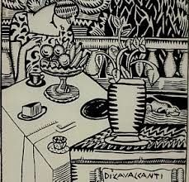

**Drawing by Emiliano di Cavalcanti in** *Klaxon*

The journal’s graphic covers with their bold colors and disproportional, experimental typography have no parallel in the later modernist journalsof Braziland its creative use of a similarly experimental visual aesthetics in its advertising, created by Guilherme de Almeida, anticipated later poetic experiments by the Brazilian poets known as the *Concretistas* — as well as angering its advertisers.

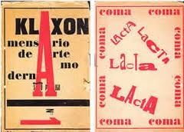

**Cover of an issue of** *Klaxon*

Luckily for the journal’s creators, many were the scion of São Paulo’s wealthiest families, making advertising an option but not a necessity. In this sense, the journal shares some similarities with earlier **Dadaist** experiments with verbal and visual forms. In fact, its influences include a diverse range of “isms” — Italian **futurism** (always tendentiously acknowledged — “KLAXON is not Futurist/ KLAXON is Klaxist,” the first issue proclaims, coining a neologism), **surrealism**, and **expressionism**, as well as the concept of *Creacionismo* developed by the Chilean avante-gardist **Vicente Huidobro**.

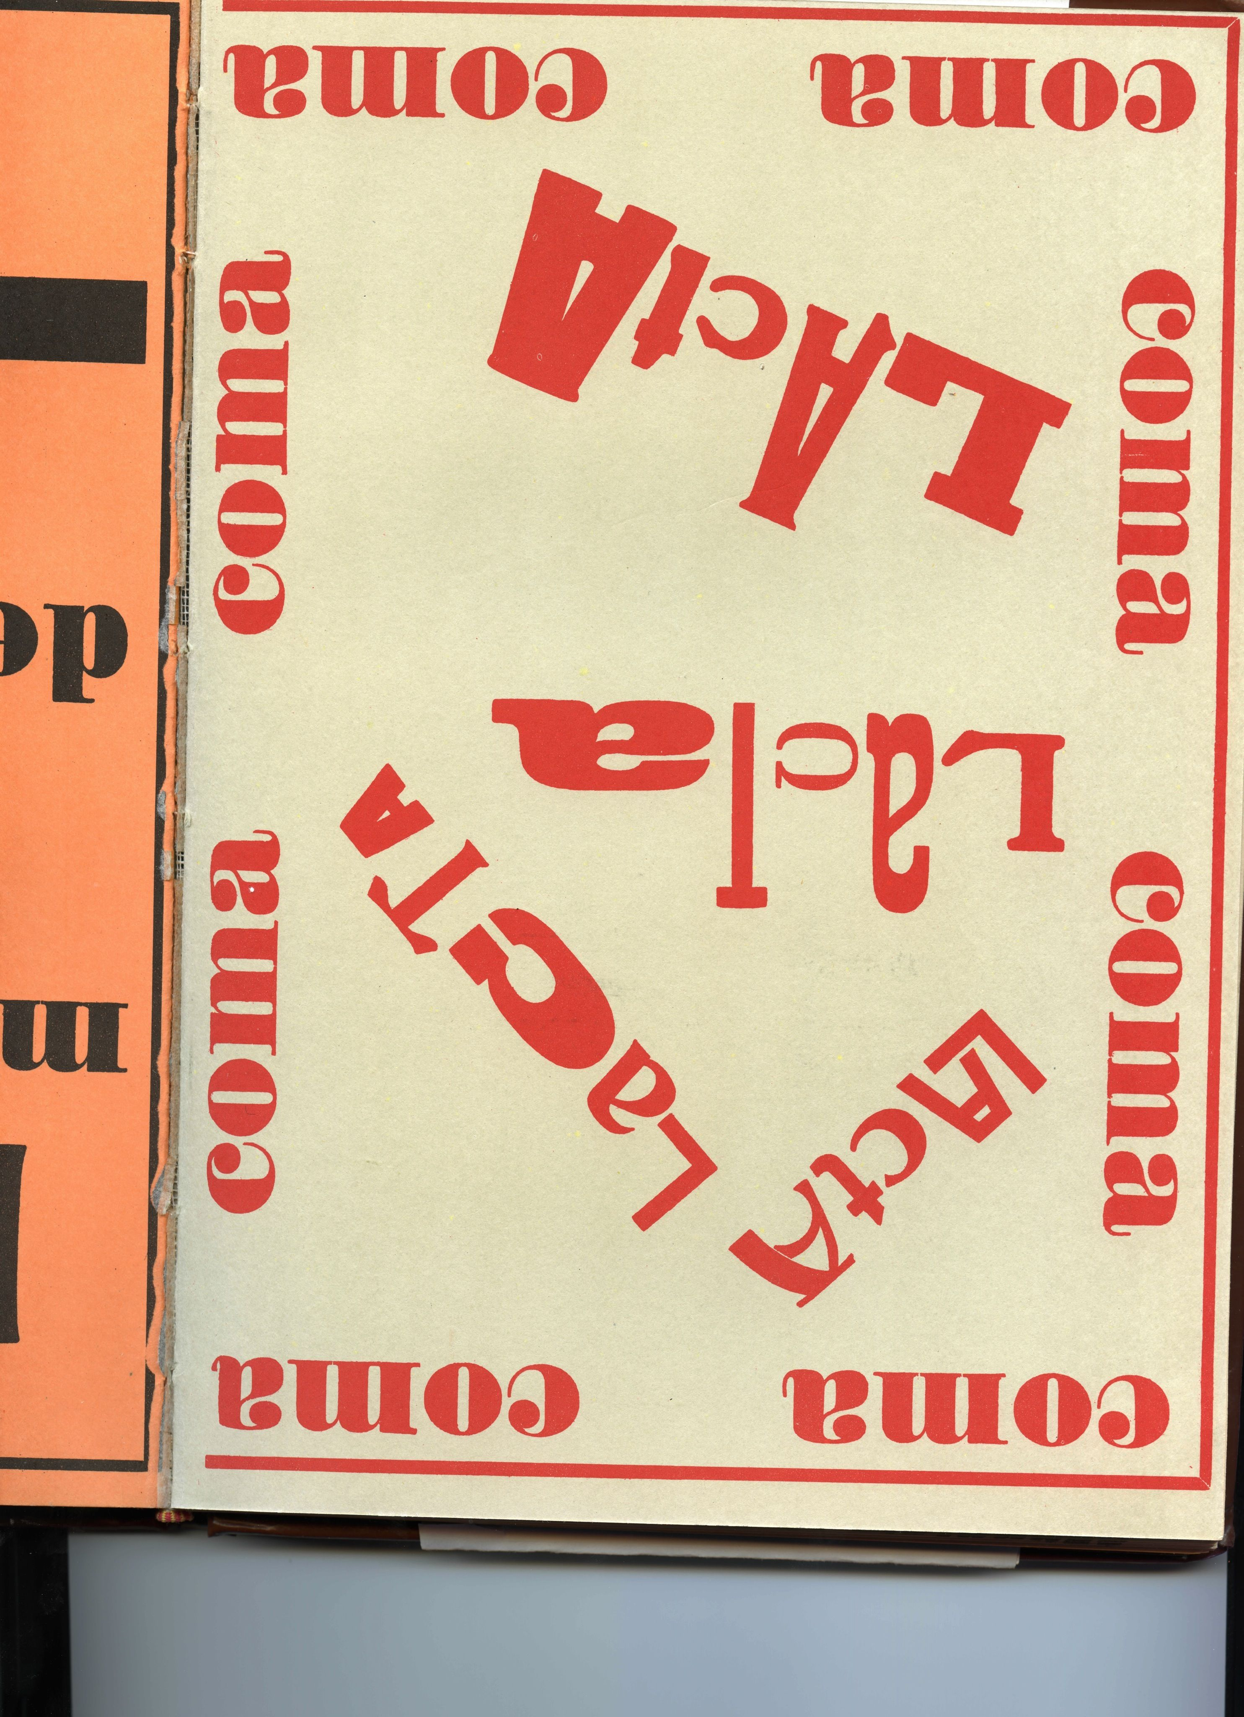

**Example of an advertisement in** *Klaxon*

The journal also glorified elements of modern life, including synchronicity, jazz, agile and punchy prose, and media and machines. These include Luís Aranha’s futurist poetic ode, “The Airplane”; frequent references to cinema, including comparing itself to the new medium, as “cinematographically dynamic” (No. 1, p. 5); and the automobile horn that gave the journal its title and positioned it at the vanguard: the klaxon is what comes before the caravan or herd. In this sense, *Klaxon* is closely linked to the seminal **Brazilian Modern Art Week,** the most audacious happening of modernist art in Latin American during the 1920s.In its opening issue, the journal declares itself the reflective mediator of this event.

Yet despite its defiant embrace of new forms, objects, and techniques, *Klaxon* also anticipates — in poems such as Mário de Andrade’s “São Pedro” and his “Poema Abúlico”— Brazilian modernism’s long-standing interest in the encounter between the hyper-modern and ostensibly “older” forms (economically eclipsed, or racially/ethnically distinct from Euro-America). Moreover, despite its triumphant language, it at times betrays its Romantic and Symbolist ancestry. *Klaxon*’s eclipse undoubtedly had many reasons, but the fact that the editors felt obligated to dedicate its last issues — the double issues 8 and 9 — to the older, supportive, yet highly criticized for his traditionalism, writer Graça Aranha signaled the limitations of its radical project in the face of a Brazilian literary and artistic culture still fundamentally bound up with a notion of “good families,” respectability, and rigid economic disparities. Yet the journal’s short life also corresponds to the ephemerality of most avant-garde experiments. In the words of its opening manifesto, the journal strove to be “polymorphous, omnipresent, energetic, comic, irritating, contradictory, envied, insulted, happy” (No. 1, p. 3), ensuring its ephemeral but lingering place in the history of Latin American modernism.

-Sarah Ann Wells, University of Notre Dame

**Further Reading**

Bosi, Alfredo (1994). *Historia concisa da literatura brasileira*. São Paulo: Editora Cultrix, 1994. (Portuguese)

Brito, Mário da Silva. “O Alegre Combate de Klaxon.” Fascimile edition of *Klaxon* – *Mensário de Arte Moderna.* São Paulo: Martins; Secretaria da Cultura, Ciência e Tecnologia do Estado de São Paulo, 1976. (Portuguese)

de Lara, Cecilia (1975). “Klaxon e Lumière.” *Cahiera du monde hispanique et luso-brésilien* 25: 77-102. (Portuguese)

Schwarz, Jorge (2002). *Las vanguardias latinoamericanas. Textos programáticos y críticos.* Mexico: Fondo de Cultura Económica: 260-264. (Spanish)

Unruh, Vicky (1994). *Latin American Vanguards: the art of contentious encounters,* Berkeley, University of California Press. (English)